

**LAB 1: INTRODUCTION TO ROBOTICS**

Name of Student: ……**OMAR**……………………………………………….

Roll No.: ………………**01-132182-024**……………………………………………….

Date of Experiment: ………………………………………………….

Report submitted on: ………………………………………………..

Marks obtained: ……………………………………

Remarks: ……………………………………………

Instructor’s Signature: ……………………………...

**Objectives:**

* + To learn about Robots and their different types.
  + To learn about Manipulators and their different types.
  + To learn about parts used in a robot.

**Tasks:**

* + **Make summary of everything that is discussed in class and submit it in pdf format.**

**Solution:**

 **Robot:**

A robot is an autonomous machine capable of sensing its environment, carrying out computations to make decisions, and performing actions in the real world.

**Fields used in Robotics:**

Robotics integrates fields of **mechanical engineering**, **electrical engineering**, **information engineering**, **mechatronics**, **electronics**, **bioengineering**, **computer engineering**, **control engineering**, **software engineering**, and **mathematics.**

In order to create a system that can **Sense, Plan, Act** the above fields are necessary.

**Parts of Robot:**

The basic parts of a robot are:

* + **Sensors:**
  + Sensors are what allow a robot to gather information about its environment. This information can be used to guide the robot's behavior. Some sensors are relatively familiar pieces of equipment. For example, **Cameras** allow a robot to construct a visual representation of its environment.
  + **Joints:**
  + Robot joints refer to the movable components of the robot that result in relative motions between adjacent links.
  + **Links:**
  + Links are used to refer to the rigid members connecting the joints for clear and adequate functioning.
  + **Controller:**
  + Robot controller is a combination of hardware and software to program and control a single or multiple robots.
  + **Power Supply:**
  + The main sources of electrical power for robots are **batteries**. The type of battery that is used for a robot varies depending on the safety, life cycle, and weight. **Lead acid** batteries are common, as are **silver cadmium** batteries.
  + **Grip:**
  + Robot grippers/tools are the physical interface between a robot arm and the work piece. This end-of-arm tooling (EOAT) is one of the most important parts of the robot. There are as many different process tools as there are different operations in manufacturing. Examples include, **robot welding tools**, **robot machining tools**, **robot painting tools**, **3D printing tools**, and the list goes on and on.

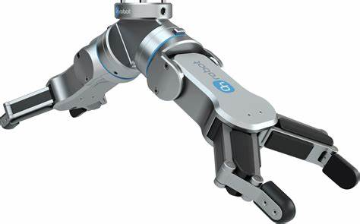

* **Basic components of Robot:**

The design of industrial robots makes them capable of performing human-like functions. This design consists of five main components which are

**Manipulators:**

* + Manipulator is the main body of the robot and consists of the links, joints, and other structural elements of the robot.
  + **Sensors:**
  + Sensors are used to collect information about the internal state of the robot or to communicate with the outside environment. Robots are often equipped with external sensory devices such as a vision system, touch and tactile sensors, speech synthesizers etc., which enables the robot to communicate with the outside world.
  + **Actuators:**
  + An actuator is a motor or valve that converts power into robot movements. There are two basic types of actuators namely linear and rotary actuators. Linear actuators provide motion along a straight line. Rotary actuators provide rotation, moving their loads in arc or circle.
  + **End Effector:**
  + End effector is the last part attached the last joint of a manipulator which generally handles objects, makes connection to other machines, or performs the required tasks. Grippers, welding torch, point spray gun, glue, laying gun etc. are some of the examples of end effector.

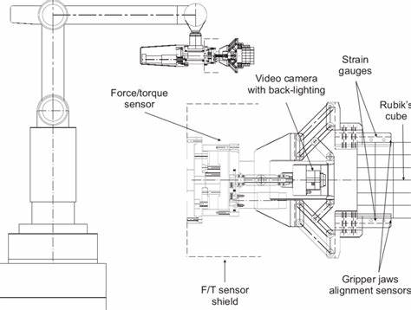

* **Geometry or kinematic structure of Robot:**

Robot kinematics applies geometry to the study of the movement of multi-degree of freedom kinematic chains that form the structure of robotic systems. The emphasis on geometry means that the links of the robot are modeled as rigid bodies and its joints are assumed to provide pure rotation or translation.

Following are the different kinematics structures of a robot:

1. **Cartesian Configuration:**

Cartesian configuration robot is so-called because the arm movement of the robot is designed to **move parallel** to the **x, y,** and **z-axis** of a cartesian coordinate system. A robot designed with this type of configuration is capable of moving its arm to any point **linearly** within a **rectangular workspace**.

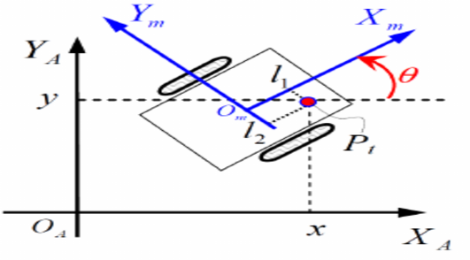

1. **Cylindrical Configuration:**

A cylindrical configuration robot is called because the arm movement of the robot is designed to move according to the cylindrical coordinate system. A robot designed with this type of configuration consists of a **vertical column** and a slide that can move up and down along the column.

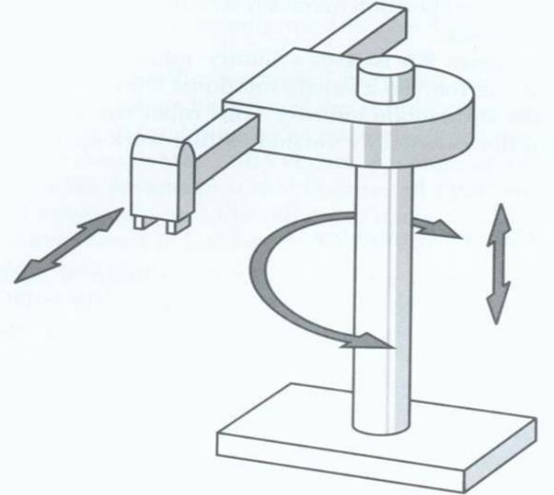

The column can rotate about a vertical axis and hence is capable of achieving a workspace that approximates a cylinder. The robot can perform this motion by extending a cylinder that’s built into the arm. In most cylindrical robots, the up-anddown motion is provided by a pneumatic cylinder, and the rotation is generally provided by a motor and gears.

1. **Spherical Configuration:**

Polar configuration is also referred to the as spherical configuration because the workspace within which a robot can move its arm is a partial sphere. A robot designed with this type of configuration consists of a rotary base and a pivot that can be used to raised and lower a telescoping arm similar to the formation of an arc movement. It has one linear and two rotary motions.

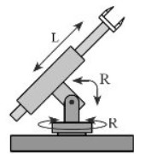

1. **Revolute Configuration:**

The revolute configuration, or jointed arm, is the most common. These robots are often referred to as anthropomorphic because their movements closely resemble those of the human arm. It also offers a more flexible reach than the other configurations, also making it ideally suited to welding and spray-painting operations.

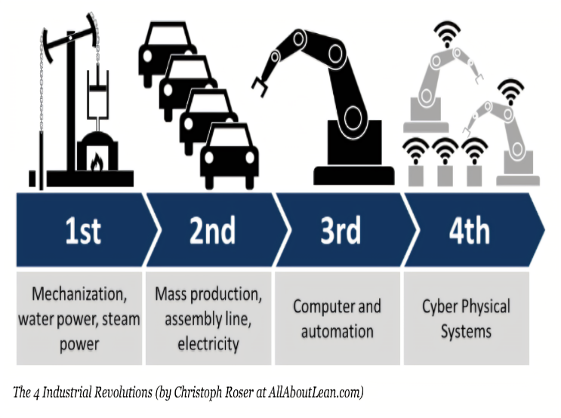

1. **SCARA Configuration:**

SCARA Robots are a popular option for small robotic assembly applications. SCARA is an acronym for Selective Compliance Articulated Robot Arm, meaning it is compliant in the X-Y axis, and rigid in the Z-axis. The SCARA configuration is unique and designed to handle a variety of material handling operations.

The SCARA’s structure consists of two arms joined at the base and the intersection of arms one and two. Two independent motors use inverse kinematics and interpolation at joints J1 and J2 to control the SCARA’s X-Y motion. The final X-Y location at the end of arm two is a factor of the J1 angle, J2 angle, length of arm one and length of arm two.

**Conclusion:**

**In this lab we learned about Industrial robots and all the parts and components that are required to make a robot. It was an introductory class for robotics in which we learned about basic, essential components of a functional industrial robots.**